**Lab Exercise 1– Install Terraform on Mac OS**

### Download Terraform File for Mac OS

To find the latest version of Terraform for Mac OS:

1. Open Terminal

2. Install Terraform

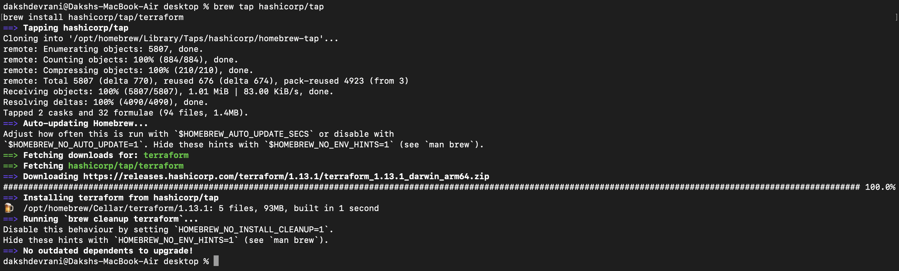

### Verify Mac OS Terraform Installation

To check the Terraform global path configuration:

1. Open a new Terminal.

2. Enter the command to check the Terraform version: terraform -version

terraform -version



The output shows the Terraform version you downloaded and installed on your Mac OS machine.